EXPERIMENT 1 - BFS for Emergency Facility Navigation
AIM: To find a route through a hospital or emergency facility.
QUESTION:
Develop a Python-based navigation system for an emergency response team operating inside a hospital represented as an unweighted graph. Rooms and junctions are vertices, while accessible corridors are edges. Implement Breadth-First Search (BFS) to identify the route from the emergency entrance to a designated critical-care unit.
The program must:
- Represent the hospital layout as an adjacency list.
- Accept the source and destination nodes.
- Find and display the shortest route in terms of the number of corridors traversed.
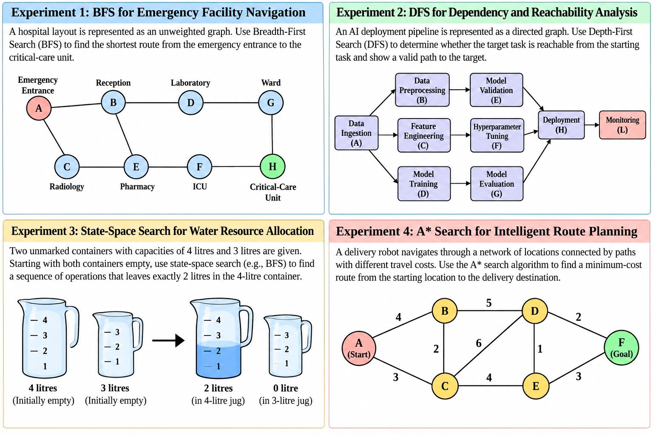
- Report the number of nodes explored and explain how BFS guarantees a shortest path in an unweighted graph.
CODE:
from collections import deque
graph = {
'A': ['B', 'C'],
'B': ['A', 'D', 'E'],
'C': ['A', 'E'],
'D': ['B', 'G'],
'E': ['B', 'C', 'F'],
'F': ['E', 'H'],
'G': ['D', 'H'],
'H': ['F', 'G']
}
def bfs(graph, start, goal):
queue = deque([start])
visited = {start}
parent = {start: None}
distance = {start: 0}
order = []
print("BFS: Hospital Navigation")
print(f"Start: {start} | Goal: {goal}\n")
while queue:
node = queue.popleft()
order.append(node)
print(f"Step {len(order)}: Node = {node}")
print(f" Queue: {list(queue)}")
if node == goal:
print(" Goal reached!")
break

for neighbor in graph[node]:
if neighbor not in visited:
visited.add(neighbor)
parent[neighbor] = node
distance[neighbor] = distance[node] + 1
queue.append(neighbor)
print(f" {node} -> {neighbor}: Added to queue")
else:
print(f" {node} -> {neighbor}: Already visited")
print(f" Visited: {sorted(visited)}")
if goal not in parent:
print("\nNo route found.")
return
path = []
current = goal
while current is not None:
path.append(current)
current = parent[current]
path.reverse()
print("\n--- Final Result ---")
print("Traversal order:", " -> ".join(order))
print("Shortest path :", " -> ".join(path))
print("Path cost :", distance[goal], "corridors")
print("Nodes explored :", len(order))
bfs(graph, 'A', 'H')

OUTPUT:
BFS: Hospital Navigation
Start: A | Goal: H
Step 1: Node = A
Queue: []
A -> B: Added to queue
A -> C: Added to queue
Visited: ['A', 'B', 'C']
Step 2: Node = B
Queue: ['C']
B -> A: Already visited
B -> D: Added to queue
B -> E: Added to queue
Visited: ['A', 'B', 'C', 'D', 'E']
Step 3: Node = C
Queue: ['D', 'E']
C -> A: Already visited
C -> E: Already visited
Visited: ['A', 'B', 'C', 'D', 'E']
Step 4: Node = D
Queue: ['E']
D -> B: Already visited
D -> G: Added to queue
Visited: ['A', 'B', 'C', 'D', 'E', 'G']
Step 5: Node = E
Queue: ['G']
E -> B: Already visited
E -> C: Already visited
E -> F: Added to queue
Visited: ['A', 'B', 'C', 'D', 'E', 'F', 'G']
Step 6: Node = G
Queue: ['F']
G -> D: Already visited
G -> H: Added to queue
Visited: ['A', 'B', 'C', 'D', 'E', 'F', 'G', 'H']
Step 7: Node = F
Queue: ['H']
F -> E: Already visited
F -> H: Already visited
Visited: ['A', 'B', 'C', 'D', 'E', 'F', 'G', 'H']
Step 8: Node = H
Queue: []
Goal reached!

--- Final Result ---
Traversal order: A -> B -> C -> D -> E -> G -> F -> H
Shortest path : A -> B -> D -> G -> H
Path cost : 4 corridors
Nodes explored : 8

EXPERIMENT 2 - DFS for Dependency and Reachability Analysis
AIM: To analyse dependencies in an AI software pipeline.
QUESTION:
An AI deployment pipeline consists of interconnected processing tasks, where each task depends on one or more downstream tasks. Model the pipeline as a directed graph and implement Depth-First Search (DFS) in Python to determine whether a specified target task is reachable from a given starting task.
The program must:
- Represent the pipeline using a directed adjacency list.
- Accept a starting task and a target task.
- Display the DFS traversal order and determine whether the target is reachable.
- Reconstruct a valid path to the target, if one exists.
- Explain how visited-node tracking prevents repeated exploration and how DFS behaves when the graph contains cycles.
CODE:
graph = {
'A': ['B', 'C', 'D'],
'B': ['E'],
'C': ['F'],
'D': ['G'],
'E': ['H'],
'F': ['H'],
'G': ['H'],
'H': ['L'],
'L':[]
}
def dfs(graph, start, goal):
visited = set()
path = []
order = []
def search(node):
visited.add(node)
order.append(node)
path.append(node)
print(f"Step {len(order)}: Node = {node}")
print(f" Current path: {' -> '.join(path)}")
if node == goal:
print(" Goal reached!")
return True
for neighbor in graph[node]:
if neighbor not in visited:
print(f" Exploring edge: {node} -> {neighbor}")

if search(neighbor):
return True
else:
print(f" Skipping {neighbor}: Already visited")
path.pop()
print(f" Backtracking from {node}")
return False
print("DFS: AI Pipeline Reachability")
print(f"Start: {start} | Goal: {goal}\n")
found = search(start)
print("\n--- Final Result ---")
print("Traversal order:", " -> ".join(order))
if found:
print("Path found :", " -> ".join(path))
print("Path length :", len(path) - 1, "edges")
else:
print("No path exists.")
print("Path found : None")
print("Nodes explored :", len(order))
dfs(graph, 'A', 'H')

OUTPUT:
DFS: AI Pipeline Reachability
Start: A | Goal: H
Step 1: Node = A
Current path: A
Exploring edge: A -> B
Step 2: Node = B
Current path: A -> B
Exploring edge: B -> E
Step 3: Node = E
Current path: A -> B -> E
Exploring edge: E -> H
Step 4: Node = H
Current path: A -> B -> E -> H
Goal reached!
--- Final Result ---
Traversal order: A -> B -> E -> H
Path found : A -> B -> E -> H
Path length : 3 edges
Nodes explored : 4

EXPERIMENT 3 - State-Space Search for Water Resource Allocation
AIM: To Measure a target quantity using containers with fixed capacities.
QUESTION:
Design a Python-based state-space search solution for a water allocation problem involving two unmarked containers with capacities of 4 litres and 3 litres. Starting with both containers empty, determine a sequence of valid operations that leaves exactly 2 litres in the 4-litre container.
The program must:
- Represent each state as the quantities of water in both containers.
- Define the legal actions: fill, empty and transfer water between containers.
- Search the state space using BFS and identify a valid solution.
- Display the sequence of states and actions from the initial state to the goal.
- Explain how state representation, goal testing and repeated-state detection affect the search.
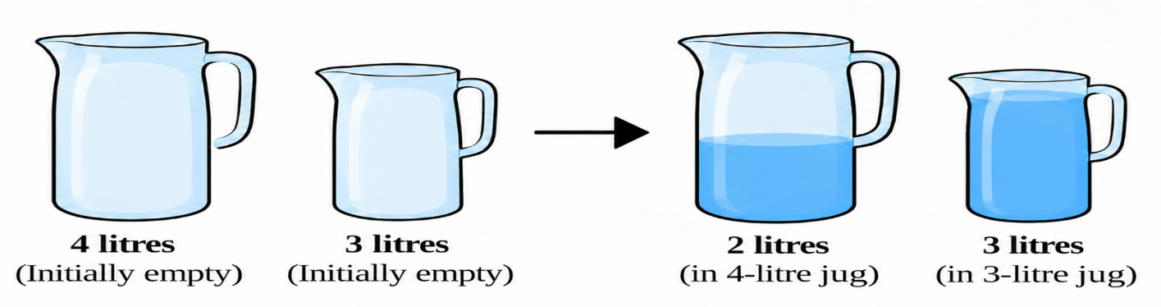

CODE:
from collections import deque
def water_jug_bfs():
start = (0, 0)
goal = 2
queue = deque([start])
visited = {start}
parent = {start: None}
action = {start: "Initial state"}
capacities = (4, 3)
def get_next_states(a, b):
states = []
# Fill either jug
states.append(((4, b), "Fill 4-litre jug"))
states.append(((a, 3), "Fill 3-litre jug"))
# Empty either jug
states.append(((0, b), "Empty 4-litre jug"))
states.append(((a, 0), "Empty 3-litre jug"))
# Pour 4-litre jug into 3-litre jug
transfer = min(a, capacities[1] - b)
states.append(((a - transfer, b + transfer),
"Pour 4-litre jug into 3-litre jug"))
# Pour 3-litre jug into 4-litre jug
transfer = min(b, capacities[0] - a)
states.append(((a + transfer, b - transfer),
"Pour 3-litre jug into 4-litre jug"))
return states
step = 0
goal_state = None

print("Water Jug Problem: State-Space Search")
print("Start state:", start)
print("Goal: Exactly 2 litres in the 4-litre jug\n")
while queue:
current = queue.popleft()
step += 1
a, b = current
print(f"Step {step}: State = {current}")
print(" Queue:", list(queue))
if a == goal:
goal_state = current
print(" Goal reached!")
break
for next_state, operation in get_next_states(a, b):
if next_state not in visited:
visited.add(next_state)
parent[next_state] = current
action[next_state] = operation
queue.append(next_state)
print(f" Action: {operation}")
print(f" New state: {next_state}")
else:
print(f" Skipped {next_state}: Already visited")
print("\n--- Final Result ---")
if goal_state is None:
print("No solution found.")
return

path = []
current = goal_state
while current is not None:
path.append(current)
current = parent[current]
path.reverse()
for i, state in enumerate(path):
print(f"Step {i}: {state} | {action[state]}")
print("\nSolution path:", " -> ".join(map(str, path)))
print("Operations required:", len(path) - 1)
print("States discovered:", len(visited))
water_jug_bfs()

OUTPUT:
Water Jug Problem: State-Space Search
Start state: (0, 0)
Goal: Exactly 2 litres in the 4-litre jug

Step 1: State = (0, 0)
Queue: []
Action: Fill 4-litre jug
New state: (4, 0)
Action: Fill 3-litre jug
New state: (0, 3)
Skipped (0, 0): Already visited
Skipped (0, 0): Already visited
Skipped (0, 0): Already visited
Skipped (0, 0): Already visited
Step 2: State = (4, 0)
Queue: [(0, 3)]
Skipped (4, 0): Already visited
Action: Fill 3-litre jug
New state: (4, 3)
Skipped (0, 0): Already visited
Skipped (4, 0): Already visited
Action: Pour 4-litre jug into 3-litre jug
New state: (1, 3)
Skipped (4, 0): Already visited
Step 3: State = (0, 3)
Queue: [(4, 3), (1, 3)]
Skipped (4, 3): Already visited
Skipped (0, 3): Already visited
Skipped (0, 3): Already visited
Skipped (0, 0): Already visited
Skipped (0, 3): Already visited
Action: Pour 3-litre jug into 4-litre jug
New state: (3, 0)
Step 4: State = (4, 3)
Queue: [(1, 3), (3, 0)]
Skipped (4, 3): Already visited
Skipped (4, 3): Already visited
Skipped (0, 3): Already visited
Skipped (4, 0): Already visited
Skipped (4, 3): Already visited
Skipped (4, 3): Already visited
Step 5: State = (1, 3)
Queue: [(3, 0)]
Skipped (4, 3): Already visited
Skipped (1, 3): Already visited
Skipped (0, 3): Already visited
Action: Empty 3-litre jug
New state: (1, 0)
Skipped (1, 3): Already visited
Skipped (4, 0): Already visited
Step 6: State = (3, 0)
Queue: [(1, 0)]
Skipped (4, 0): Already visited
Action: Fill 3-litre jug
New state: (3, 3)
Skipped (0, 0): Already visited
Skipped (3, 0): Already visited
Skipped (0, 3): Already visited
Skipped (3, 0): Already visited
Step 7: State = (1, 0)
Queue: [(3, 3)]
Skipped (4, 0): Already visited
Skipped (1, 3): Already visited
Skipped (0, 0): Already visited
Skipped (1, 0): Already visited
Action: Pour 4-litre jug into 3-litre jug
New state: (0, 1)
Skipped (1, 0): Already visited
Step 8: State = (3, 3)
Queue: [(0, 1)]
Skipped (4, 3): Already visited
Skipped (3, 3): Already visited
Skipped (0, 3): Already visited
Skipped (3, 0): Already visited
Skipped (3, 3): Already visited
Action: Pour 3-litre jug into 4-litre jug
New state: (4, 2)
Step 9: State = (0, 1)
Queue: [(4, 2)]
Action: Fill 4-litre jug
New state: (4, 1)
Skipped (0, 3): Already visited
Skipped (0, 1): Already visited
Skipped (0, 0): Already visited
Skipped (0, 1): Already visited
Skipped (1, 0): Already visited
Step 10: State = (4, 2)
Queue: [(4, 1)]
Skipped (4, 2): Already visited
Skipped (4, 3): Already visited
Action: Empty 4-litre jug
New state: (0, 2)
Skipped (4, 0): Already visited
Skipped (3, 3): Already visited
Skipped (4, 2): Already visited
Step 11: State = (4, 1)
Queue: [(0, 2)]
Skipped (4, 1): Already visited
Skipped (4, 3): Already visited
Skipped (0, 1): Already visited
Skipped (4, 0): Already visited
Action: Pour 4-litre jug into 3-litre jug
New state: (2, 3)
Skipped (4, 1): Already visited
Step 12: State = (0, 2)
Queue: [(2, 3)]
Skipped (4, 2): Already visited
Skipped (0, 3): Already visited
Skipped (0, 2): Already visited
Skipped (0, 0): Already visited
Skipped (0, 2): Already visited
Action: Pour 3-litre jug into 4-litre jug
New state: (2, 0)
Step 13: State = (2, 3)
Queue: [(2, 0)]
Goal reached!

--- Final Result ---
Step 0: (0, 0) | Initial state
Step 1: (4, 0) | Fill 4-litre jug
Step 2: (1, 3) | Pour 4-litre jug into 3-litre jug
Step 3: (1, 0) | Empty 3-litre jug
Step 4: (0, 1) | Pour 4-litre jug into 3-litre jug
Step 5: (4, 1) | Fill 4-litre jug
Step 6: (2, 3) | Pour 4-litre jug into 3-litre jug

Solution path: (0, 0) -> (4, 0) -> (1, 3) -> (1, 0) -> (0, 1) -> (4, 1) -> (2, 3)
Operations required: 6
States discovered: 14

EXPERIMENT 4 - A* Search for Intelligent Route Planning
APPLICATION: To route planning for an autonomous delivery robot.
QUESTION
Develop an intelligent route-planning system for an autonomous delivery robot navigating a network of locations connected by paths with different travel costs. Implement the A* search algorithm in Python to find a minimum-cost route from a specified starting location to a delivery destination.
The program must:
- Represent the environment as a weighted graph.
- Assign a heuristic estimate \(h(n)\) to each node and calculate the accumulated path cost \(g(n)\).
- Use \(f(n)=g(n)+h(n)\) to determine which node to explore next.
- Display the selected route, total path cost and node expansion order.
- Explain how heuristic quality affects search efficiency and why an admissible heuristic matters for optimality.
Heuristic values.
Node | h(n)
A | 6
B | 4
C | 5
D | 2
E | 3
F | 0

CODE:
import heapq
# Weighted graph from the experiment image
graph = {
'A': [('B', 4), ('C', 3)],
'B': [('A', 4), ('C', 2), ('D', 5)],
'C': [('A', 3), ('B', 2), ('D', 6), ('E', 4)],
'D': [('B', 5), ('C', 6), ('E', 1), ('F', 2)],
'E': [('C', 4), ('D', 1), ('F', 3)],
'F': [('D', 2), ('E', 3)]
}
# Estimated cost from each node to goal F
h = {
'A': 6,
'B': 4,
'C': 5,
'D': 2,
'E': 3,
'F': 0
}
def astar(start, goal):
# Priority queue entries: (f, node, g, path)
open_list = [(h[start], start, 0, [start])]
best_g = {start: 0}
expanded = []
print("A* Search: Intelligent Route Planning")
print(f"Start: {start} | Goal: {goal}\n")
while open_list:
f, node, g, path = heapq.heappop(open_list)

# Ignore outdated entries
if g != best_g.get(node):
continue
expanded.append(node)
print(f"Step {len(expanded)}: Expand {node}")
print(f" g(n)={g}, h(n)={h[node]}, f(n)={f}")
if node == goal:
print(" Goal reached!")
break
for neighbor, cost in graph[node]:
new_g = g + cost
new_f = new_g + h[neighbor]
if new_g < best_g.get(neighbor, float('inf')):
best_g[neighbor] = new_g
new_path = path + [neighbor]
heapq.heappush(
open_list,
(new_f, neighbor, new_g, new_path)
)
print(
f" {node}->{neighbor}: "
f"g={new_g}, h={h[neighbor]}, f={new_f} "
f"| Updated"
)
else:
print(f" {node}->{neighbor}: No better cost")
pending = sorted(
(item[1], item[2], item[0])
for item in open_list
if item[2] == best_g.get(item[1])
)
print(" OPEN (node, g, f):", pending, "\n")
if node == goal:
print("--- Final Result ---")
print("Optimal path :", " -> ".join(path))
print("Total path cost :", g)
print("Nodes expanded :", len(expanded))
print("Expansion order :", " -> ".join(expanded))
else:
print("No route found.")
astar('A', 'F')

OUTPUT:
A* Search: Intelligent Route Planning
Start: A | Goal: F

Step 1: Expand A
g(n)=0, h(n)=6, f(n)=6
A->B: g=4, h=4, f=8 | Updated
A->C: g=3, h=5, f=8 | Updated
OPEN (node, g, f): [('B', 4, 8), ('C', 3, 8)]

Step 2: Expand B
g(n)=4, h(n)=4, f(n)=8
B->A: No better cost
B->C: No better cost
B->D: g=9, h=2, f=11 | Updated
OPEN (node, g, f): [('C', 3, 8), ('D', 9, 11)]

Step 3: Expand C
g(n)=3, h(n)=5, f(n)=8
C->A: No better cost
C->B: No better cost
C->D: No better cost
C->E: g=7, h=3, f=10 | Updated
OPEN (node, g, f): [('D', 9, 11), ('E', 7, 10)]

Step 4: Expand E
g(n)=7, h(n)=3, f(n)=10
E->C: No better cost
E->D: g=8, h=2, f=10 | Updated
E->F: g=10, h=0, f=10 | Updated
OPEN (node, g, f): [('D', 8, 10), ('F', 10, 10)]

Step 5: Expand D
g(n)=8, h(n)=2, f(n)=10
D->B: No better cost
D->C: No better cost
D->E: No better cost
D->F: No better cost
OPEN (node, g, f): [('F', 10, 10)]

Step 6: Expand F
g(n)=10, h(n)=0, f(n)=10
Goal reached!
--- Final Result ---
Optimal path : A -> C -> E -> F
Total path cost : 10
Nodes expanded : 6
Expansion order : A -> B -> C -> E -> D -> F

